DATA PENELITIAN
No | Kode | CETR | Transfer Pricing | Profitabilitas | Kepemilikan Institusional | Financial Distress
1 | ADRO 2016 | -0,3326 | 0,0009 | 0,0522 | 0,4391 | -2,3941
2 | ADRO 2017 | -0,5625 | 0,0004 | 0,0787 | 0,4391 | -2,1104
3 | ADRO 2018 | -0,5053 | 0,0092 | 0,0676 | 0,4391 | -2,1132
4 | ADRO 2019 | -0,4796 | 0,0376 | 0,0603 | 0,4391 | -2,7749
5 | ADRO 2020 | -0,8465 | 0,0585 | 0,0248 | 0,4391 | -0,2621
6 | ADRO 2021 | -0,2061 | 0,0472 | 0,1356 | 0,4391 | -0,2604
7 | APEX 2016 | -0,6308 | 0,0083 | 0,0280 | 0,8397 | -0,8498
8 | APEX 2019 | -0,0251 | 0,0176 | 0,0407 | 0,8398 | -0,5155
9 | APEX 2020 | -0,0088 | 0,1561 | 0,0109 | 0,8698 | -0,3584
10 | APEX 2021 | -0,0306 | 0,0568 | 0,1244 | 0,8698 | -0,3113
11 | BUMI 2016 | -0,1629 | 0,0635 | 0,0388 | 0,2942 | -0,3706
12 | BUMI 2017 | -1,0235 | 0,4312 | 0,0657 | 0,2623 | -0,2197
13 | BUMI 2018 | -0,7539 | 0,3630 | 0,0405 | 0,2267 | -0,1368
14 | BUMI 2019 | -4,8581 | 0,2998 | 0,0026 | 0,2267 | -1,1808
15 | BUMI 2021 | -0,4203 | 0,3047 | 0,0529 | 0,2645 | -3,9024
16 | BYAN 2016 | -1,1518 | 0,0371 | 0,0231 | 0,3726 | -5,0748
17 | BYAN 2017 | -0,1007 | 0,0325 | 0,3803 | 0,3427 | -2,9113
18 | BYAN 2018 | -0,2189 | 0,0191 | 0,4556 | 0,3271 | -3,4366
19 | BYAN 2019 | -0,6827 | 0,0749 | 0,1833 | 0,3000 | -6,7576
20 | BYAN 2020 | -0,1414 | 0,0434 | 0,2127 | 0,1000 | -0,2476
21 | BYAN 2021 | -0,0735 | 0,1813 | 0,5202 | 0,1000 | -1,3955
22 | DOID 2016 | -0,3404 | 0,4118 | 0,0420 | 0,3921 | -1,4715
23 | DOID 2017 | -0,4614 | 0,0104 | 0,0494 | 0,3816 | -1,3514
24 | DOID 2018 | -0,3437 | 0,0080 | 0,0639 | 0,3790 | -0,8963
25 | DOID 2019 | -0,7930 | 0,0083 | 0,0173 | 0,3787 | -1,7166
26 | DOID 2021 | -0,6165 | 0,0058 | 0,0002 | 0,3786 | -1,8378
27 | DSSA 2016 | -0,0845 | 0,2261 | 0,0290 | 0,5990 | -1,5464
28 | DSSA 2017 | -0,1211 | 0,2338 | 0,0465 | 0,5990 | -1,3940
29 | DSSA 2018 | -0,3888 | 0,2624 | 0,0357 | 0,5990 | -2,5358
30 | DSSA 2019 | -0,3787 | 0,1676 | 0,0193 | 0,5990 | -4,2573
31 | DSSA 2021 | -0,1716 | 0,3265 | 0,0881 | 0,5990 | -1,0169
32 | ENRG 2017 | -1,4637 | 0,6718 | 0,0169 | 0,1463 | -1,2129
33 | ENRG 2019 | -0,5205 | 0,6367 | 0,0361 | 0,4377 | -1,7646
34 | ENRG 2020 | -0,5675 | 0,6471 | 0,0694 | 0,3993 | -3,3346
35 | ENRG 2021 | -0,8113 | 0,5873 | 0,0373 | 0,5134 | -3,3254
36 | GEMS 2016 | -0,1008 | 0,1666 | 0,0926 | 0,9700 | -2,9510
37 | GEMS 2017 | -0,1073 | 0,2310 | 0,2034 | 0,9700 | -2,7409
38 | GEMS 2018 | -0,5190 | 0,1456 | 0,1434 | 0,9700 | -2,6080
39 | GEMS 2019 | -0,4177 | 0,0793 | 0,0855 | 0,9700 | -4,2950
40 | GEMS 2020 | -0,0086 | 0,0971 | 0,1178 | 0,9700 | -5,4436
41 | GEMS 2021 | -0,0021 | 0,0788 | 0,4270 | 0,9250 | -6,2349
42 | HRUM 2016 | -0,0472 | 0,1489 | 0,0432 | 0,7370 | -5,1507
43 | HRUM 2017 | -0,1893 | 0,2175 | 0,1213 | 0,7414 | -7,1263
44 | HRUM 2018 | -0,5782 | 0,1905 | 0,0859 | 0,7414 | -8,1986
45 | HRUM 2019 | -0,5735 | 0,3189 | 0,0450 | 0,7918 | -3,3461
46 | HRUM 2020 | -0,0592 | 0,3758 | 0,1209 | 0,7988 | -1,2811
47 | HRUM 2021 | -0,0671 | 0,5962 | 0,1124 | 0,7988 | -1,7873
48 | INDY 2017 | -0,1635 | 0,1097 | 0,0885 | 0,6844 | -1,5002
49 | INDY 2018 | -1,0283 | 0,0944 | 0,0267 | 0,6844 | -1,9386
50 | INDY 2019 | -4,2640 | 0,1218 | 0,0014 | 0,6844 | -3,5107
51 | INDY 2021 | -0,3326 | 0,1582 | 0,0172 | 0,6844 | -0,9401
52 | MBSS 2019 | -0,5294 | 0,1664 | 0,0083 | 0,7668 | -0,9512
53 | MEDC 2016 | -0,0903 | 0,4701 | 0,0520 | 0,8045 | -0,8206
54 | MEDC 2017 | -0,5690 | 0,4349 | 0,0255 | 0,7292 | -3,0951
55 | MEDC 2021 | -0,7031 | 0,0487 | 0,0110 | 0,7366 | -4,1068
56 | PTBA 2016 | -0,2678 | 0,0186 | 0,1090 | 0,2894 | -4,3586
57 | PTBA 2017 | -0,1847 | 0,0085 | 0,2068 | 0,7106 | -4,2011
58 | PTBA 2018 | -0,3101 | 0,0186 | 0,2119 | 0,7106 | -3,7187
59 | PTBA 2019 | -0,2809 | 0,0194 | 0,1548 | 0,6694 | -4,1951
60 | PTBA 2020 | -0,2048 | 0,0550 | 0,1001 | 0,6791 | -1,7950
61 | PTBA 2021 | -0,1262 | 0,0044 | 0,2225 | 0,6612 | -1,8773
62 | PTRO 2016 | -0,5526 | 0,1289 | 0,0199 | 0,6980 | -1,9897
63 | PTRO 2017 | -0,2230 | 0,0980 | 0,0262 | 0,6980 | -2,1205
64 | PTRO 2018 | -0,0910 | 0,1682 | 0,0417 | 0,6980 | -2,0790
65 | PTRO 2019 | -0,3189 | 0,1908 | 0,0568 | 0,6980 | -2,3719
66 | PTRO 2020 | -0,4247 | 0,4694 | 0,0614 | 0,6980 | -1,3025
67 | PTRO 2021 | -0,1646 | 0,3488 | 0,0637 | 0,6980 | -1,3798
68 | SOCI 2016 | -0,0006 | 0,4869 | 0,0381 | 0,7990 | -1,2795
69 | SOCI 2017 | -0,0006 | 0,2933 | 0,0367 | 0,7990 | -1,3285
70 | SOCI 2018 | -0,0016 | 0,2459 | 0,0200 | 0,7990 | -1,6069
71 | SOCI 2019 | -0,0015 | 0,2340 | 0,0136 | 0,7990 | -1,6494
72 | SOCI 2020 | -0,0008 | 0,4203 | 0,0414 | 0,7990 | -2,2809
73 | SOCI 2021 | -0,0021 | 0,4558 | 0,0086 | 0,7990 | -2,4171
74 | TOBA 2016 | -0,5027 | 0,5090 | 0,0558 | 0,9314 | -2,2942
75 | TOBA 2017 | -0,2193 | 0,4562 | 0,1188 | 0,9326 | -1,8393
76 | TOBA 2018 | -0,2784 | 0,2318 | 0,1357 | 0,9326 | -1,2020
77 | TOBA 2019 | -0,2799 | 0,0898 | 0,0689 | 0,9326 | -1,6589
78 | TOBA 2020 | -0,1471 | 0,0631 | 0,0464 | 0,9326 | -2,5077
79 | TOBA 2021 | -0,0595 | 0,0537 | 0,0765 | 0,9326 | 1,6589
80 | WINS 2021 | -0,2289 | 0,3243 | 0,0032 | 0,3417 | 2,5077

HASIL PENGOLAHAN DATA

  - Uji Deskriptif
Descriptive Statistics
 | N | Minimum | Maximum | Mean | Std. Deviation
CETR | 80 | -4,8581 | -,0006 | -,443760 | ,7292403
TP | 80 | ,0004 | ,6718 | ,201125 | ,1840619
Profitab | 80 | ,0002 | ,5202 | ,086467 | ,0998327
KI | 80 | ,1000 | ,9700 | ,625874 | ,2391992
FD | 80 | -8,1986 | ,1368 | -2,364874 | 1,6618628
Valid N (listwise) | 80

  - Uji Asumsi Klasik
One-Sample Kolmogorov-Smirnov Test
 |  | Unstandardized Residual
N |  | 80
Normal Parameters^{a,b} | Mean | ,0000000
Normal Parameters^{a,b} | Std. Deviation | ,66946548
Most Extreme Differences | Absolute | ,237
Most Extreme Differences | Positive | ,198
Most Extreme Differences | Negative | -,237
Test Statistic |  | ,237
Asymp. Sig. (2-tailed) |  | ,000^{c}
a. Test distribution is Normal.
b. Calculated from data.
c. Lilliefors Significance Correction.

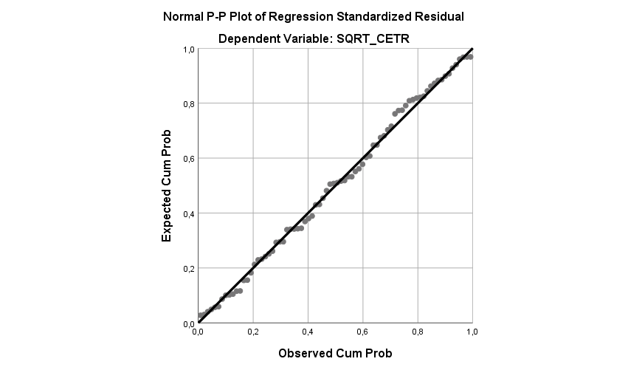

One-Sample Kolmogorov-Smirnov Test
 |  | Unstandardized Residual
N |  | 76
Normal Parameters^{a,b} | Mean | ,0000000
Normal Parameters^{a,b} | Std. Deviation | ,23200768
Most Extreme Differences | Absolute | ,058
Most Extreme Differences | Positive | ,050
Most Extreme Differences | Negative | -,058
Test Statistic |  | ,058
Asymp. Sig. (2-tailed) |  | ,200^{c,d}
a. Test distribution is Normal.
b. Calculated from data.
c. Lilliefors Significance Correction.
d. This is a lower bound of the true significance.

Coefficientsª
Model |  | Collinearity Statistics
 |  | Tolerance | VIF
1 | SQRT_TP | ,917 | 1,090
1 | SQRT_ROA | ,745 | 1,343
1 | SQRT_KI | ,925 | 1,081
1 | SQRT_Z | ,741 | 1,350
a. Dependent Variable: SQRT_CETR

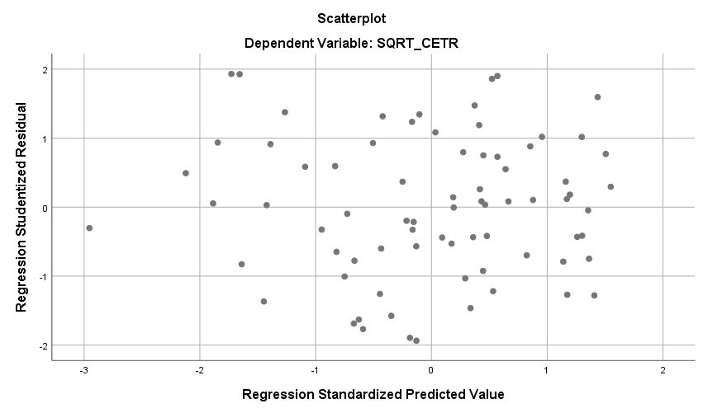
Coefficientsª
Model |  | Unstandardized Coefficients |  | Standardized Coefficients | t | Sig.
 |  | B | Std. Error | Beta | t | Sig.
1 | (Constant) | ,200 | ,184 |  | 1,086 | ,281
1 | SQRT_TP | -,116 | ,097 | -,140 | -1,197 | ,235
1 | SQRT_ROA | ,237 | ,207 | ,149 | 1,149 | ,254
1 | SQRT_KI | -,101 | ,070 | -,167 | -1,435 | ,156
1 | SQRT_Z | -,029 | ,031 | -,121 | -,932 | ,354
a. Dependent Variable: ABS_RES4

Runs Test
 | Unstandardized Residual
Test Valueª | ,00739
Cases < Test Value | 38
Cases >= Test Value | 38
Total Cases | 76
Number of Runs | 35
Z | -,924
Asymp. Sig. (2-tailed) | ,356
a. Median

  - Uji Regresi Linear Berganda dan Uji Hipotesis
Model Summary
Model | R | R Square | Adjusted R Square | Std. Error of the Estimate
1 | ,508ª | ,258 | ,216 | ,23845
a. Predictors: (Constant), SQRT_Z, SQRT_TP, SQRT_KI, SQRT_ROA

ANOVAª
Model |  | Sum of Squares | df | Mean Square | F | Sig.
1 | Regression | 1,403 | 4 | ,351 | 6,168 | ,000^{b}
1 | Residual | 4,037 | 71 | ,057
1 | Total | 5,440 | 75
a. Dependent Variable: SQRT_CETR
b. Predictors: (Constant), SQRT_Z, SQRT_TP, SQRT_KI, SQRT_ROA

Coefficientsª
Model |  | Unstandardized Coefficients |  | Standardized Coefficients | t | Sig.
 |  | B | Std. Error | Beta | t | Sig.
1 | (Constant) | -,559 | ,344 |  | -1,627 | ,108
1 | SQRT_TP | ,327 | ,181 | ,193 | 1,809 | ,075
1 | SQRT_ROA | ,866 | ,386 | ,266 | 2,243 | ,028
1 | SQRT_KI | ,491 | ,131 | ,398 | 3,749 | ,000
1 | SQRT_Z | ,022 | ,059 | ,045 | ,381 | ,704
a. Dependent Variable: SQRT_CETR

