Sragen Regency Government Concerning the Policy of Designating Protected Paddy Land in the Perspective of the Rule of Law

Mustofa Ponco Wibowo,Lego Karjoko
mustofa.pw@student.uns.ac.id
legokarjoko@staff.uns.ac.id

Faculty of Law, Universitas Sebelas Maret, Indonesia
Faculty of Law, Universitas Sebelas Maret, Indonesia

Article Info | Abstract
Received:  Revised:  Accepted:  Keywords:  Validity; Policy; Protected Paddy Fields; Food Security | Ensuring the well-being of the population requires the Sragen district government to prioritize food security as a crucial policy. However, the implementation of this policy faces challenges due to its conflict with the Sragen district Spatial Planning Regional Regulation. Consequently, it becomes imperative to thoroughly investigate the validity of the policy's stipulations. The purpose of this article is to elucidate the policy's validity, employing normative qualitative research methods, supplemented by statutory and conceptual approaches, and employing deductive analyzing information. The study's results suggest a noteworthy revelation that the policy concerning protected paddy fields was formulated without adhering to proper legal procedures, thereby rendering it invalid and failing to meet the necessary requirements.

Erlina: Implementation of Legal Protection of Geographical Indication of …… 1

I. Introduction
Human life depends on food, an essential need that not only includes human rights and moral responsibilities, but also becomes an investment instrument that forms an economic and social foundation, with all its natural wealth, ecosystems and cultural heritage, Indonesia is an invaluable resource. in its efforts, guma presents a brighter future for future generations. The potential and unique diversity of local agriculture must be utilized optimally in order to strengthen food security at the local, regional and national levels, and strengthen it. If each local community strengthens its capacity to maintain sustainable food supply according to the uniqueness of its region, as a whole a strong and sustainable national food security will be realized in the long term.
Currently, Indonesia is faced with emerging problems in the agricultural sector, where fertile land that was previously used for growing food, especially rice fields, is being converted into a facility for infrastructure development that is increasingly expanding, including road networks and settlements. However, in the midst of this situation, efforts to develop land expansion outside Java Island have not yet reached the standard of productivity that has been formalized universally. As a result, the resulting rice production was of poor quality, exacerbating the current situation. Conversion of agricultural land for food has become a phenomenon in almost all regions, one of which is in Sragen Regency, where this region has become an important force in the agricultural sector with the main focus as a supporting pillar of food security, both on a local and national scale. With the full involvement of all components of society in realizing food self-sufficiency in Sragen, Sragen Regency plays a role as the main support for food needs at the national level. With a land area of 39 thousand hectares, this area is capable of producing around 517 thousand tons of agricultural products, making it the second rank in Central Java, after Cilacap Regency. Thus, the consequences arising from changes in land use include challenges to food sustainability. For the food agriculture sector, land is a fundamental element and cannot be replaced. Unlike production declines due to attack by pest organisms, water shortages, flooding, and other temporary factors decline in production due to changes in land use is permanent and difficult .
A sustainable reduction in the area of agricultural land clearly does not benefit the position of Indonesia's agricultural industry progress. In the midst of uncertainty in the global economic climate, weather anomalies that have the potential to cause disasters, and an ever-increasing budget deficit, it is necessary to revise essential policies on the strategy and priority hierarchies of development programs. In order to support national food security, the government implemented regulations controlling the transformation of rice fields with the declaration of Protected Agricultural Areas (LSD) as a manifestation of the government's seriousness in maintaining the continuity of agricultural land.
Peraturann Presiden 59 Tahun 2019 is the exclusive legal basis for monitoring the transformation of rice fields, which aims to accelerate the declaration of protected agricultural landscapes to guarantee and maintain the abundance of rice fields to support demands to meet domestic hunger, control of changes fast-moving agricultural areas, empowering farmers so they don't change agricultural land, and providing datasets and information about the region
agriculture to establish sustainable agricultural areas that focus on food, this Presidential Decree orders the establishment of an Integrated Team. The task of the Integrated Team is to combine the verification results and recommend areas of rice fields that need to be protected. To speed up the implementation of this Presidential Decree, the Coordinating Minister for the Economy issued the Coordinating Minister for the Economy No. 18 Yr. 2020 and Kep. Coordinating Minister for the Economy No 224 Th. 2020 which regulates the responsibilities, work procedures and members of the Integrated Team.
The first step in protecting agricultural areas is through verification of raw rice fields using satellite observations, spatial planning and land use data, irrigation information, topographical data, and information on forest areas. After that, clarification was carried out with the local government. The synergy between the Integrated Team was used to form a map proposing the determination of agricultural areas that need to be guarded by the Minister of ATR/BPN. This map is the main basis for controlling the transformation of agricultural areas which will be made by the Minister of Agrarian Affairs/BPN.
Implementation of Presidential Decree 59 Th. 2019 has been pioneered in 2019 by carrying out a series of verification of agricultural land in 8 provinces which are the main pillars of food security in Indonesia (Banten, West Java, East Java, Central Java, DIY, Bali, NTB, also West Sumatra). This action then carried out verification in 2020 in 12 additional provinces (Aceh, North Sumatra, Jambi, Kep. Riau, Riau, Bengkulu, Kep. Babel, Lampung, South Sumatra, South Kalimantan, West Kalimantan and South Sulawesi), and in 2021, verification will be carried out in 13 more provinces (Central Kalimantan, East Kalimantan, Kaltara, West Sulawesi, Central Sulawesi, Southeast Sulawesi, North Sulawesi, Gorontalo, Maluku, North Maluku, NTT, Papua and Pabar). After going through a careful verification and clarification process, agricultural lands in the 20 provinces will be designated as Agricultural Areas Receiving Special Protection in 2021. After going through a series of intensive investigations on fertile and fertile rice fields in eight provinces which collectively form the backbone of Indonesian agriculture (Banten, West Java, East Java, Central Java, DIY, Bali, NTB and West Sumatra). ATR/BPN brilliantly announced the invaluable Extraordinary Decision Output, namely Letter No.1589/SK-HK.02.01/XII/2021 regarding the Determination of Hidden Treasures in the form of Prioritized Fertile Land Maps in Regencies/Cities in the Middle Provinces is proudly covered in the regions of Banten, West Java, East Java, Central Java, DIY, Bali, NTB and West Sumatra. The issuance of the decree turned out to have problems, especially in the Sragen Regency area.
SK 1589/SK-HK.02.01/XII/2021 given by the Ministry of ATR/BPN is considered to have violated the provisions contained in the Sragen Regency Regional Regulation No. 1 of 2020 regarding Sragen Regency Spatial Planning (RTRW) 2011-2031, where during the drafting of the Regional Regulation, the Sragen Regency Government has conducted lengthy discussions with the Ministry of Agrarian and Spatial Planning. /BPN and there is an agreement regarding the area of sustainable rice fields in Sragen which is included in the national food buffer zone. However, after examining simultaneously the map contained in Perda No. 1 of 2020 concerning RTRW and the map contained in the LSD Determination Decree, it turns out that there are areas that are considered contradictory, where the area on the map contained in the Perda RTRW already has approval for manufacturing areas and approval of areas colored yellow for settlements, etc., while on the LSD Determination map the areas included in the yellow zones of the Regional Regulations on the Regional Regulations have the status of green zones, meaning that the green zones on the LSD determination map are designated as protected agricultural areas. Even though the Sragen Regency Regional Regulation No. 1 of 2020 concerning the RTRW of the Regency. Sragen 2011-2031 was inaugurated long before SK 1589/SK-HK.02.01/XII/2021 which regulates the Determination of Maps of Protected Agricultural Areas in Regencies/Cities in the Provinces of Banten, West Java, East Java, Central Java, DIY, Bali, NTB, and West Sumatra . Based on this, the authors formulate a problem statement, namely what is the validity of the policy for determining protected agricultural areas in Sragen district? a big enough problem, namely in order to maintain the continuity of the national food supply as well as the development of industry, housing, and others to continue.

Research Method
The author applies a normative research approach that focuses on qualitative. Amiruddin and Asikin explained that in this study of law, law is often specified as written regulatory texts (law in books), or as rules governing human behavior that are deemed appropriate, appropriate, and reasonable. Then the strategy applied is the statutory strategy and conceptual approach, while the information processing procedure chosen is the deductive data analysis method.

Results and Discussion

LSD through official document number 1589/SK-HK.02.01/XII/2021 concerning Printing Image of Earth for Protected Paddy Field Gardens in Selected Areas in Banten, West Java, East, Central, Archipelago, Yogyakarta, the Island of the Gods Bali, NTB, and Minangkabau Sumbawa, describes a form of regional management policy issued by the ATR/BPN. According to J.H. van Kreveld, there are various types of policy norms covering various forms, such as Beleidslijnen (policy pathways), Het beleid (policies), Voorschriften (directives), Richtlijnen (directions), Regelingen (guidelines), Circular News (circulars), Resoluties (official decisions), Aanschrijvingen (instructions), Beleidsnota's (policy documents), Reglemen menistriele (ministerial regulations), Beschikkingen (determinations), and Enbekenmakingen (notices) . Each of these forms of policy has a different form, nature or character and legal force, as well as SK 1589/SK-HK.02.01/XII/2021. This policy provision is solely intended as an implementation of governmental responsibilities, therefore it cannot change or violate existing legislative regulations, and also the law can be understood as a whole that has a purpose (purposeful) and has meaning (meaningful). . These regulatory actions are carried out by entities or government administration officials without being entrusted with the basic authority to make them. Thus free action in making policy regulations is a complement to the principle of legality, but does not mean overriding statutory regulations, because regulations and fundamental principles of quality government are used as standards for determining the truth and legitimacy of legal steps taken by the government. Therefore, the policy for determining agricultural areas is protected through SK 1589/SK-HK.02.01/XII/2021 regarding the Determination of Protected Agricultural Area Maps in Regencies/Cities in Prov. Banten, West Java, East Java, Central Java, DIY, Bali, NTB and W Sumatra need to be discussed regarding the validity/legitimacy of these policies, bearing in mind that this is a problem in its implementation and is also being discussed in writing this law.
Legitimacy/Validity of Government Decisions and Actions
Ketika pemerintah berada di persimpangan pengambilan keputusan penting (beschikking), mereka wajib menghargai dan mengindahkan parameter-partameter yang ditentukan. Ketentuan-ketentuan penetapan wilayah pertanian dilindungi sudah diatur dalam Perpres No. 59 tahun 2019, yang menekankan pentingnya regulasi terkait perubahan fungsi wilayah pertanian. Selanjutnya, Permenko Bidang Perekonomian yang dirilis dengan No.18 tahun 2020, Yang merinci secara terperinci pekerjaan dan kewajiban Tim Terpadu Pengendalian Alih Fungsi Wilayah pertanian dan Tim Pelaksana Pengendalian Alih Fungsi Wilayah pertanian. Jika kondisi tertentu tidak terpenuhi, keputusan yang diambil akan menjadi tidak sah. Ketetapan yang diambil oleh lembaga pemerintahan adalah tindakan resmi yang terikat hukum dengan implikasi legal, sehingga apabila validitas suatu keputusan yang dilakukan oleh pemerintah diragukan, sebab itu, ketidakberlakuan suatu ketetapan pemerintah terkait dengan kecacatan pelaksanaan yang terjadi. Dalam kata lain, jika persyaratan pengambilan keputusan tidak dipenuhi, hal tersebut berpotensi mengakibatkan cacat-cacat yang menghasilkan ketetapan yang tidak valid. (niet-rechtgelding).
Pada umumnya, dapat ditemukan dua bentuk keputusan yang menonjol, yakni keputusan yang memiliki keabsahan hukum (beschikking rechtsgeldig) dan keputusan yang tidak memiliki keabsahan hukum (beschikking niet-rechtsgeldig). Untuk keputusan yang memiliki keabsahan hukum (beschikking rechtsgeldig), tidaklah mengundang implikasi hukum yang signifikan, sementara keputusan yang tidak memiliki keabsahan hukum (beschikking niet-rechtsgeldig) mungkin menghasilkan konsekuensi hukum yang berarti. Selain itu, bahkan dapat dicatat bahwa menurut Fuller ada kemungkinan lain bahwa produk hukum, salah satunya adalah keputusan, mungkin tidak memiliki validitas "inner morality", tetapi dapat dibenarkan sesuai dengan tujuan sosial.
Merujuk pandangan Kuntjoro Purbopranoto, guna memastikan kelaziman keputusan yang diambil, terdapat dua prasyarat yang wajib terpenuhi, yakni persyaratan substansial dan persyaratan formal. Persyaratan substansial menjadi syarat esensial bagi keputusan yang sah, mencakup:
- Penetapan harus ditangani oleh badan pemerintahan yang berkuasa (berhak);
- Dalam penentuan keputusan oleh badan pemerintahan, sangat penting untuk menghindari segala kekurangan hukum yang mungkin terjadi (geen yurisdiche gebreken in de welsvorming);
- Penetapan wajib diberikan dalam wujud yang diatur pada aturan perundang-undangan yang mendasarinya dan pengambil keputusan juga wajib menyimak metode penentuan keputusan apabila prosedur tersebut dijelaskan secara kategoris dalam regulasi legislasi (rechtmatig);
- Materi dan maksud keputusan harus sejalan dengan esensi serta target yang ingin diraih (doelmatig).

Sedangkan persyaratan formal menjadi syarat esensial keputusan, mencakup:
- Kriteria yang diputuskan berkaitan dengan persiapan pengambilan keputusan dan terkait dengan metode pengambilan keputusan yang harus terpenuhi;
- Wajib diberikan tampilan yang telah ditetapkan;
- Segala persyaratan yang terkait dengan implementasi keputusan telah terpenuhi;
- Perlu ditetapkan suatu periode yang jelas antara terbitnya hak yang mendasari pembuatan keputusan dan pengumuman, dan hal tersebut tidak boleh terabaikan.
Agar tercatat sebagai resmi, syarat formil yang diajukan oleh Kuntjoro Purbopranoto sebelumnya akan kehilangan keabsahannya apabila tak disahkan oleh pihak berwenang dalam pemerintahan. Oleh sebab itu, diperlukan penambahan elemen baru yang tidak kalah penting: Disahkan oleh pejabat pemerintah yang memiliki kapasitas untuk mengambil keputusan.

Alat Ukur Keabsahan/Validitas Tindak Pemerintahan
Undang-undang dan peraturan merupakan pilar esensial dalam mengemban wewenang pemerintahan. Dasar etika yang mendasari pelaksanaan kekuasaan ini dikenal sebagai legalitas (legaliteit), yang mengimplikasikan bahwa suatu tindakan pemerintah sah jika didasarkan pada aturan hukum yang memberi otoritas untuk bertindak. Prinsip legalitas (legalitiet beginsel) membentuk salah satu elemen yang tak dapat dipisahkan dalam tatanan hukum suatu negara, sebagaimana disuarakan oleh ten Berge. Selain itu, ada pula asas legalitas yang dikemukakan oleh Lon L Fuller sebagai nilai yang harus diwujudkan oleh undang-undang yaitu peraturan tidak boleh saling bertentangan, dan harus ada kesesuaian antara perbuatan para pejabat hukum dalam peraturan tersebut yang telah dibuat.
Mencermati pendapat di atas, maka asas legalitas merupakan pilar esensial dalam tindakan pemerintah. Sejatinya, tindakan yang diimplementasikan oleh pemerintah yang tidak berlandaskan azas legalitas atau undang-undang ialah sebuah aksi sewenang-wenang atau penyalahgunaan kekuasaan yang melahirkan ketidakberlakuan hukum dari tindakan tersebut. Dalam istilah lain, sahnya langkah pemerintah dalam menunaikan tugasnya bergantung pada landasan hukum yang menjadi pijakan kewenangannya.
Terlebih lagi, dalam ranah administrasi hukum, terdapat sebuah prinsip yang dikenal sebagai "dat het bestuur aan de wet is onderwopen"¹⁵ dan "het legaliteitsbeginsel houdt in dat alle de burgers bindende bepalingen op de wet moeten berusten". Ide pokok ini dirumuskan H.D. Stout menyiratkan bahwa pemerintah harus patuh pada peraturan-peraturan yang telah ditetapkan; dan prinsip legalitas menegaskan bahwa semua peraturan yang mengikat penduduk setiap negara haruslah berdasarkan pada perundang-undangan. Dengan demikian, dapat diterima pemahaman bahwa prinsip legalitas ialah satu dari pijakan yang dipegang teguh dalam negara berhukum dan dijadikan sebagai fondasi dalam menjalankan tugas-tugas pemerintahan.
Asas legalitas sangat terhubung dengan suatu mandat untuk beraksi, di mana mandat tersebut diatur dalam suatu peraturan yang berlaku. Karena norma kewenangan merupakan norma pemerintah, maka dapat digunakan dua alat ukur untuk mengukur validitas/keabsahan tindakan pemerintah, yaitu peraturan perundang-undangan; dan Asas Umum Pemerintahan yang Baik (aaupb). Validitas itu dibangun atas efektifitas seluruh tatanan hukum. Dalam konteks ini, keberhasilan sebagai landasan sah, atau bahkan menjadi pijakan utama untuk memvalidasi segala norma hukum yang terperinci dalam peraturan hukum.
Oleh sebab itu, berdasarkan penjabaran dari teori-teori tersebut dan juga berdasarkan Perpres No.59 Tahun 2019 yang mengemban tanggung jawab terhadap Pengendalian Alih Fungsi Wilayah pertanian, serta Permenko Bidang Perekonomian No.18 Tahun 2020 yang membahas Tata Kerja Tim Terpadu Pengendalian Alih Fungsi Wilayah pertanian Dan Tim Pelaksana Pengendalian Alih Fungsi Wilayah pertanian, terlihat jelas bahwa SK 1589/SK-HK.02.01/XII/2021 yang mengesahkan perlindungan terhadap wilayah pertanian, diragukan keabsahannya dalam konteks penetapan keputusan wilayah pertanian dilindungi di Kabupaten Sragen. Kekurangan validitas terlihat nyata saat tahapan penetapan wilayah pertanian dilindungi di wilayah tersebut dan tanpa adanya koordinasi dengan pemerintah daerah kabupaten Sragen, sehingga terjadi perbedaan peta dan terjadi ketidaksinkronan antara peta wilayah penetapan wilayah pertanian yang dilindungi dengan peta rencana tata ruang wilayah kabupaten Sragen, selain itu juga dalam proses penetapannya peta rencana tata ruang wilayah tersebut sudah lebih dulu ditetapkan daripada peta wilayah penetapan wilayah pertanian yang dilindungi. Hal tersebut menjadi pertentangan dalam penetapan keputusan wilayah pertanian dilindungi.
Peta wilayah penetapan wilayah pertanian yang dilindungi berdasarkan SK 1589/SK-HK.02.01/XII/2021 di Kab Sragen sebesar 43.799,61 hektare ditetapkan sebagai wilayah pertanian dilindungi. Lalu ada perbedaan data antara penetapan wilayah pertanian dilindung dengan RTRW di Sragen, selisihnya hampir 10.000 hektar, dimana Setelah melakukan evaluasi terhadap sejumlah proyek, terdapat sejumlah investasi yang terkendala oleh Kekurangan Sumber Daya, mencakup sekitar 9.000 hektar, yang keseluruhannya merupakan lahan pertanian. Berikut adalah perbedaan peta antara penetapan Wilayah pertanian Dilindungi dengan RTRW Di Sragen:
- Peta Wilayah pertanian Dilindungi
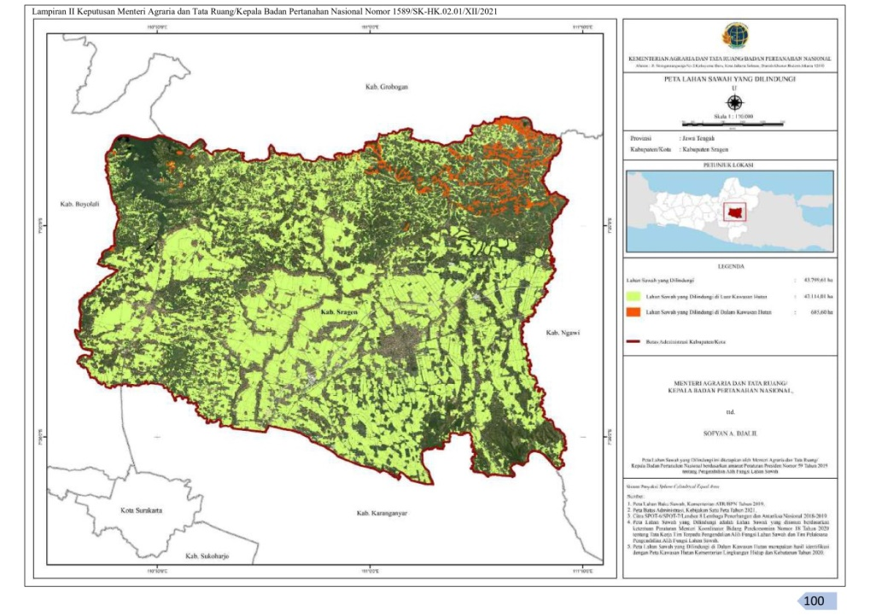
Sumber : SK No.1589/SK-HK.02.01/XII/2021
Keterangan :
___ : Lingkup pertanian Dilindungi di luar kawasan hutan
___ : Lingkup pertanian Dilindungi di luar kawasan hutan

- Peta Rencana Tata Ruang Wilayah Kabupaten Sragen
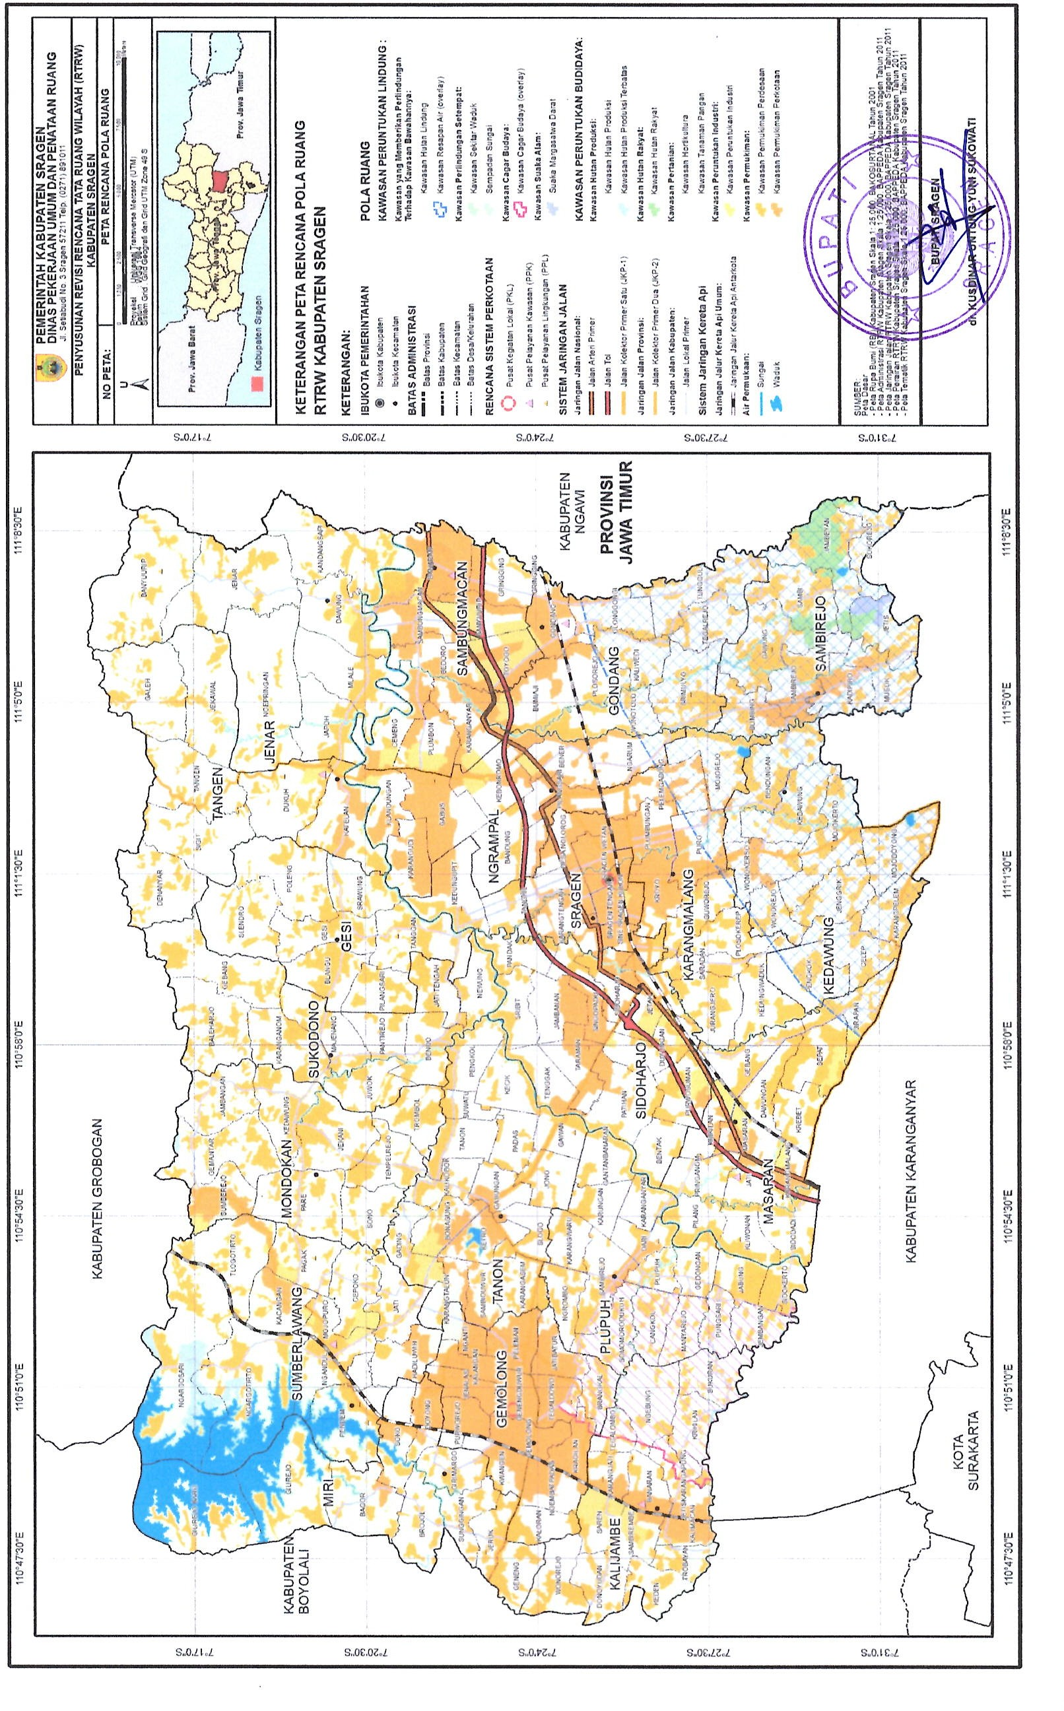
Sumber : Perda Kabupaten Sragen No.1 Tahun 2020
Keterangan :
___ : Kawasan hutan rakyat
___ : Area industri
___ : Area perdesaan
___ : Area perkotaan
Dari situlah dapat diperhatikan bahwa terdapat sebuah perbedaan antara peta penetapan Wilayah pertanian Dilindungi dengan peta RTRW Di Sragen. Wilayah dalam peta yang seharusnya akan digunakan sebagai kawasan industri, didalam peta wilayah pertanian dilindungi termasuk dalam wilayah wilayah pertanian yang dilindungi, yang artinya tidak dapat dialihfungsikan. Perbedaan antara kedua peta itulah dapat disimpulkan bahwa peta penetapan wilayah pertanian dilindungi yaitu SK 1589/SK-HK.02.01/XII/2021 dinilai tidak memenuhi ketentuan-ketentuan/unsur-unsur validitas sehingga terjadinya ketidaksinkronan antara peta penetapan Wilayah pertanian Dilindungi dengan peta RTRW Di Sragen. Kebijakan pemerintah dapat dinyatakan tidak memenuhi unsur validitas apabila melalaikan sekumpulan petunjuk dalam suatu entitas kerangka hukum yang teratur. Sebuah sistem hukum akan kehilangan esensi keberlakuannya ketika norma-norma hukum yang terdapat dalam struktur tersebut tidak pernah mampu terealisasikan sepenuhnya. Oleh karena itu, segala peraturan hukum yang ada dalam suatu sistem hukum merupakan kepunyaan tunggal dari satu kerangka peraturan hukum yang serupa karena keabsahannya.
Dalam proses penetapan wilayah pertanian dilindungi terdapat berbagai ketentuan dan Penegakan norma yang wajib dijalankan sesuai dengan aturan hukum yang berlaku, sebab peraturan perundang-undangan memiliki peranan strategis sebagai instrumen dan jalan yang efektif dalam mengendalikan serta mengarahkan perjalanan masyarakat menuju target yang diidamkan. Ketentuan dan tata cara dalam proses penetapan wilayah pertanian dilindungi tersebut sudah diatur dalam Perpres No. 59 Tahun 2019 yang menetapkan Aturan Strategis Alih Fungsi Area Pertanian dan Instruksi Mentri Koor. Bidang Perekonomian No. 18 Tahun 2020 yang mengatur Tata Kelola Tim Komprehensif Alih Fungsi Wilayah pertanian beserta Tim Pelaksana untuk Mengendalikan Alih Fungsi Wilayah pertanian.
Pengkajian tata guna lahan pertanian menjalankan serangkaian langkah eksklusif, meliputi pencocokan wilayah pertanian yang terverifikasi, harmonisasi akurasi hasil pencocokan wilayah pertanian, serta eksekusi penentuan peta wilayah pertanian yang diprioritaskan. Proses bisnis tersebut dilaksanakan oleh Tim Terpadu, Tim Pelaksana dan 2 (dua) Satuan Tugas yang berasal dari kementerian/lembaga terkait melalui koordinasi, integrasi data dan kolaborasi dalam mencari solusi atas suatu permasalahan. Rencananya, Ketua Tim Terpadu Pengendalian Alih Fungsi Wilayah pertanian akan mengusulkan ATR/BPN guna menetapkan sebuah peta eksklusif yang mencerminkan lahan padi yang dijaga dengan cermat.
- Verifikasi Data Wilayah pertanian
Verifikasi dilakukan berdasarkan LBS terbaru yang diputuskan ATR/BPN (Penyedia Informasi Geospasial Tematik) dengan interpretasi citra satelit terbaru dan data pendukung geospasial lainnya sehingga terdapat koreksi terhadap data LBS. Kemudian Verifikasi data LBS juga terkoreksi dengan antara lain : dengan tata ruang (RTRW Kabupaten/ Kota dan Rencana Detail Tata Ruang) dan data pertanahan, dengan Daerah Irigasi, dengan cetak sawah baru, dengan Proyek Strategis Nasional, dengan Kegiatan Industri, dengan Kawasan Hutan.
- Klarifikasi Data Wilayah pertanian
Kegiatan Verifikasi dan Klarifikasi Data Lapangan dijalankan oleh setiap departemen/lembaga yang digerakkan oleh entitas struktural yang bertanggung jawab mengurusi makanan dan agribisnis di lingkungan Kemenko Bidang Perekonomian. Klarifikasi merupakan bagian dari proses verifikasi untuk menghasilkan data indikatif LSD sebagai hasil verifikasi dan klarifikasi.
- Sinkronisasi dan Pengusulan Peta Wilayah pertanian yang Dilindungi
Menyelesaikan masalah yang masih mengambang di antara anggota Tim Eksekutif dan mencapai kesepakatan yang harmonis di antara berbagai departemen dan lembaga terkait mengenai Penetapan Areal Pertanian yang Perlu Diawasi, yang akan diresmikan ATR/BPN. Rakor tersebut bertujuan agar peta wilayah pertanian dilindungi menjadi peta yang dapat dipertanggungjawabkan oleh seluruh kementerian/lembaga terkait serta pemda. Rapat koordinasi dipimpin oleh Ketua Tim Terpadu dan dikunjungi Anggota Tim Terpadu.
- Pemantauan Dan Evaluasi Terhadap Pelaksanaan Pengendalian Alih Fungsi Wilayah pertanian
Penelusuran serta penilaian kinerja dalam mengaplikasikan strategi peralihan peran wilayah pertanian dilakukan oleh Satuan Tugas Pemantauan dan Evaluasi terhadap implementasi pengawasan perubahan pemanfaatan ladang dengan tujuan meningkatkan efektivitas pengelolaan ladang yang dilindungi sesuai dengan ketentuan yang telah diputuskan ATR/BPN. Selain itu juga untuk penegakan hukum dalam hal terdapat indikasi pelanggaran alih fungsi wilayah pertanian yang dilindungi. Penyelidikan dan Penilaian terhadap implementasi pengamanan perubahan tugas lahan pertanian yang terlindungi meliputi : Kegiatan Pemantauan Pelaksanaan Pengendalian Alih Fungsi Wilayah pertanian yang Dilindungi dan Kegiatan Evaluasi Pelaksanaan Pengendalian Alih Fungsi Wilayah pertanian.

Conclusion
Proses penetapan wilayah pertanian dilindungi terdapat berbagai macam ketentuan-ketentuan dan tindakan yang wajib dijalankan sejalan dengan norma hukum yang berlaku. Ketentuan dan prosedur dalam proses penetapan wilayah pertanian dilindungi tersebut sudah diatur dalam Perpres No. 59 Tahun 2019 mengenai Rezim Pengendalian Perubahan Fungsi Lahan Pertanian dan Keputusan Menko Bidang Ekonomi No.18 Tahun 2020 yang membahas Proses Kolaboratif Tim Terpadu untuk Mengatur Alih Fungsi Lahan Pertanian. Tahapan penetapan Laporan Status Wilayah pertanian yang Harus Dijaga tetap produktif terdiri dari verifikasi wilayah pertanian, keserasian hasil verifikasi wilayah pertanian dan pelaksanaan penentuan Laporan Status Wilayah pertanian yang Perlu Dijaga. Penetapan wilayah pertanian dilindungi dapat dinyatakan valid/memenuhi unsur validitas apabila dilaksanakan melalui proses tersebut mematuhi regulasi hukum yang berlaku, dan apabila tahapan-tahapan tersebut dilaksanakan apabila tidak memenuhi tata hukum yang berlaku, maka keabsahannya diragukan.
- Suggestion
Penelitian selanjutnya diharapkan dapat menelaah lebih lanjut mengenai tindakan/kebijakan yang dikeluarkan oleh pemerintah dengan menggunakan atau meninjau dengan teori dan undang-undang yang lain sehingga dapat menemukan jawaban yang lebih komprehensif mengenai kebijakan yang dikleuarkan oleh pemerintah dari sudut pandang yang lain dan mungkin bisa menemukan sebuah temuan baru.

References
Amiruddin dan Asikin. 2004. Pengantar Metode Penelitian Hukum. Jakarta: PT Raja Grafindo Persada.
Departemen Pertanian. 2006. Naskah Akademik Pengelolaan Lahan Pertanian Abadi. Jakarta: Departemen Pertanian Republik Indonesia.
Esmi Warasih, 2005. Pranata Hukum Sebuah Telaah Sosiologis. Semarang: Suryanadaru Utama.
E. Utrecht. 1986. Pengantar Hukum Administrasi Negara Indonesia. Surabaya: Pustaka Tinta Mas, p. 108-114.
H.D. Stout. 1994. De Betekenissen van de Wet. W.E.J.Tjeenk Willink, Zwolle.
J.H. van Kriveld. 1983. Beleidsregel in het Recht. Kluwer Deventer.
Kasumbogo U. 2010. Penerapan Pertanian Berkelanjutan Untuk Meningkatkan Ketahanan Pangan. Jakarta.
Kuntjoro Purbopranoto. 1981. Perkembangan Hukum Administrasi Indonesia. Bandung: Binacipta.
Ridwan HR. 2002. Hukum Administrasi Negara. Yogyakarta: UII Press.
Ali Marwan Hsb. 2017. “Kegentingan yang Memaksa dalam Pembentukan Peraturan Pemerintah Pengganti Undang-Undang”. Jurnal Legislasi Indonesia. Vol. 14 No. 01. Pp. 109-122.
Atip Latipulhayat. 2014. “Khazanah: Hans Kelsen”. Padjajaran Jurnal Ilmu Hukum. Vol. 01 No. 01. Pp. 196-208. DOI: https://doi.org/10.22304/pjih.v1n1.a12
Ida Keumala Jeumpa, 2014. “Contempt Of Court: Suatu Perbandingan Antara Berbagai Sistem Hukum”. Kanun Jurnal Ilmu Hukum. Vol. 16 No. 62. Pp. 147-176.
Mhd. Yusrizal Adi Syaputra. 2016. “Kajian Yuridis Terhadap Penegasan Hierarki Peraturan Perundang undangan di Indonesia Dalam Perspektif Stufen Theorie”. Jurnal Mercatoria. Vol. 09 No. 02. Pp. 95-103.
DOI: https://doi.org/10.31289/mercatoria.v9i2.433
Muhammad Zulfikar, et.al. 2013. “Pemetaan Wilayah Pertanian Dan Potensinya Untuk Perlindungan Lahan Pertanian Pangan Berkelanjutan Di Kabupaten Pasaman Barat, Sumatera Barat”. Jurnal Ilmu Tanah dan Lingkungan. Vol. 15 No. 1. Pp. 20-28. DOI: https://doi.org/10.29244/jitl.15.1.20-28
Petrus CKL Bello. 2012. “Hukum Sebagai Interpretasi”. DISKURSUS – Jurnal Filsafat Dan Teologi. Vol. 11 No. 01. Pp. 61-78.
DOI: https://doi.org/10.36383/diskursus.v11i1.155
Ricca Anggraeni & Indah Mutiara Sari. 2020. “Menelisik Tertib Hukum Peraturan Pemerintah Pengganti Undang-Undang Melalui Validitas Suatu Noma Hukum”. Jurnal Crepido. Vol. 02 No. 01. Pp. 35-45.
DOI: https://doi.org/10.14710/crepido.2.1.35-45
Romi Prayudi, 2020, Teori Hukum Pandangan Ahli Hukum Alam Dan Hukum Positif. Paper Ilmiah, Fakultas Hukum UPN Veteran Jakarta, p. 8.
Defiyan Cory, 2021, “Produktivitas Pangan Dan Penyusutan Lahan Pertanian Di Indonesia”, Diakses melalui: https://bisnisnews.id/detail/berita/produktifitas-pangan-dan-penyusutan-lahan-pertanian-di-indonesia diakses pada tanggal 10 Juni 2022
Effendi Rois, 30 Maret 2022, “Bupati Sragen Curhat ke Ganjar Pranowo Soal Wilayah pertanian Dilindungi”, Diakses melalui: https://www.tvonenews.com/daerah/jateng/34122-bupati-sragen-curhat-ke-ganjar-pranowo-soal-lahan-sawah-dilindungi diakses pada tanggal 03 Juni 2023
Kementrian Koordinator Bidang Perekonomian, 12 Maret 2021, “Penetapan LSD Bukti Keseriusan Pemerintah Menjaga Wilayah pertanian”. Diakses melalui: https://www.ekon.go.id/publikasi/detail/2565/penetapan-lsd-bukti-keseriusan-pemerintah-menjaga-lahan-sawah diakses pada tangal 02 September 2022
Yandip Provinsi Jawa Tengah, 8 Februari 2017, “Kabupaten Sragen Sebagai Penyangga Pangan Nomor 2 Di Jawa Tengah”, Diakses melalui: https://jatengprov.go.id/beritadaerah/kabupaten-sragen-sebagai-penyangga-pangan-nomor-2-di-jawa-tengah/ diakses pada tanggal 21 Maret 2023
Peraturan Menteri Koordinator Bidang Perekonomian Nomor 18 Tahun 2020 tentang Tata Kerja Tim Terpadu Pengendalian Alih Fungsi Wilayah pertanian Dan Tim Pelaksana Pengendalian Alih Fungsi Wilayah pertanian

Muhammad Zulfikar, et.al, “Pemetaan Wilayah pertanian Dan Potensinya Untuk Perlindungan Lahan Pertanian Pangan Berkelanjutan Di Kabupaten Pasaman Barat, Sumatera Barat”, Jurnal Ilmu Tanah dan Lingkungan, Vol. 15, No. 1, 2013, p. 21.
Departemen Pertanian. 2006. Naskah Akademik Pengelolaan Lahan Pertanian Abadi. Departemen Pertanian Republik Indonesia. Jakarta.
Kementrian Koordinator Bidang Perekonomian, 12 Maret 2021, “Penetapan LSD Bukti Keseriusan Pemerintah Menjaga Wilayah pertanian”. Diakses melalui: https://www.ekon.go.id/publikasi/detail/2565/penetapan-lsd-bukti-keseriusan-pemerintah-menjaga-lahan-sawah diakses pada tangal 02 September 2022
E. Utrecht, 1986, Pengantar Hukum Administrasi Negara Indonesia, Surabaya: Pustaka Tinta Mas, p. 108-114.
Romi Prayudi, 2020, Teori Hukum Pandangan Ahli Hukum Alam Dan Hukum Positif. Paper Ilmiah, Fakultas Hukum UPN Veteran Jakarta, p. 8.
Kuntjoro Purbopranoto, 1981, Perkembangan Hukum Administrasi Indonesia. Bandung: Binacipta, p. 48-49.
Ridwan HR, 2002, Hukum Administrasi Negara, Yogyakarta: UII Press, p. 8.
Esmi Warasih, 2005, Pranata Hukum Sebuah Telaah Sosiologis, Semarang : Suryanadaru Utama, p. 31.
Atip Latipulhayat, 2014, “Hans Kelsen”, Padjajaran Jurnal Ilmu Hukum, Vol. 01, No. 01, p. 204
Effendi Rois, 30 Maret 2022, “Bupati Sragen Curhat ke Ganjar Pranowo Soal Wilayah pertanian Dilindungi”, Diakses melalui: https://www.tvonenews.com/daerah/jateng/34122-bupati-sragen-curhat-ke-ganjar-pranowo-soal-lahan-sawah-dilindungi diakses pada tanggal 03 Juni 2023
Ida Keumala Jeumpa, 2014, “Contempt Of Court: Suatu Perbandingan Antara Berbagai Sistem Hukum”, Kanun Jurnal Ilmu Hukum, No. 62, Th. XVI, p. 153-154.
Ricca Anggraeni & Indah Mutiara Sari, 2020, “Menelisik Tertib Hukum Perpres Pengganti Undang-Undang Melalui Validitas Suatu Noma Hukum”, Jurnal Crepido, Vol. 02, No. 01, p. 39-40.
Mhd. Yusrizal Adi Syaputra, 2016, “Kajian Yuridis Terhadap Penegasan Hierarki Peraturan Perundang undangan di Indonesia Dalam Perspektif Stufen Theorie”, Mercatoria, Vol. 09, No. 02, p. 99.
Ali Marwan Hsb, 2017, “Kegentingan yang Memaksa dalam Pembentukan PP Pengganti Undang-Undang”, Jurnal Legislasi Indonesia, Vol. 14, No. 01, p. 111.
Permen Koordinator Bidang Perekonomian Nomor 18 Tahun 2020 tentang Tata Kerja Tim Terpadu Pengendalian Alih Fungsi Wilayah pertanian Dan Tim Pelaksana Pengendalian Alih Fungsi Wilayah pertanian.

